Jesse Agbenyega Zola Henry M1
FMIG Vice President Candidate

I’m running for FMIG VP because I have a history of enjoying and excelling at positions that require providing various forms of support, in academia, health care, and elsewhere. Adaptability has been the main characteristic which has allowed me to do this. For example, I worked for about 2 years in a psychiatric hospital. I started as a psych aide and took on the roles of secretary and code responder, simply because it was needed and I was able to. In this hybridized position, some of my days were as calm as: clocking in at 8am, organizing papers, doing vitals and clocking out at 4pm. Other times, I pulled 16 hour shifts taking vitals, arguing down police that wanted to illegally obtain patient information, and responding to unit codes to help restrain aggressive and violent patients. As Vice President for 2015-16, I see myself not only supporting and filling in for the president when needed, but also aiding the treasurer in calculating budgets and collecting dues, helping class liaisons with reaching out to and enticing potential new members, and assisting the secretary with meeting minutes and other documentation. From a member’s perspective, I enjoyed how the E-board was run this year, so there’s little I want to change to be honest. My classmates and I specifically enjoyed the panels of residents that would come speak to us so that’s one thing I wanted would really want to see continue. Those of us who already wanted to become family physicians would feel an extra dose of inspiration after such discussions. If elected, I would be really excited to learn who the E-board members will be, so we can figure out what we can create as a team. Finally, I would like to emphasize that I have a very strong interest in both family medicine, and the recruitment of primary care physicians. I currently serve as a case manager at 12 south clinic, and I’ve been able get a head start on developing a second sense of continuous patient accountability. I came to medical school to become the family physician that I didn’t have. Thank you for reading this, and I hope I can earn your vote.

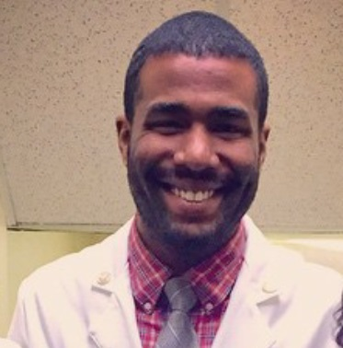
Best regards,
J. A. Zola Henry

