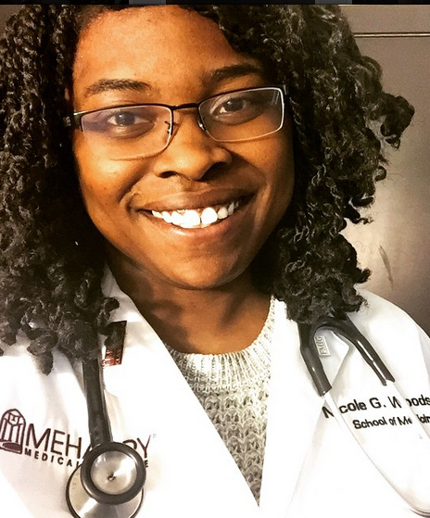
Ahh SNAP!
NICOLE WOODSON
FOR HISTORIAN

Hello Family Medicine Interest Group!
My name is Nicole Woodson and I want to be FMIG Historian. As your historian, I plan to snap amazing pictures that capture the bold and the beautiful of FMIG. To accomplish this goal, I will attend events and take pictures often. Along with the duties of updating the electronic databases and webpages, I also want to spread the word of what a great group FMIG by starting a Meharry FMIG Instagram. This will keep us connected as a group and show the campus what the future Family medicine doctors are made of! You should vote for me because as the class of 2018 Academic Vice President this past year, I proved to be organized, thorough, and hard working. I also enjoy taking pictures of other people (I don’t like taking pictures of myself) and I love FMIG!

